Non-Union, SAG-E
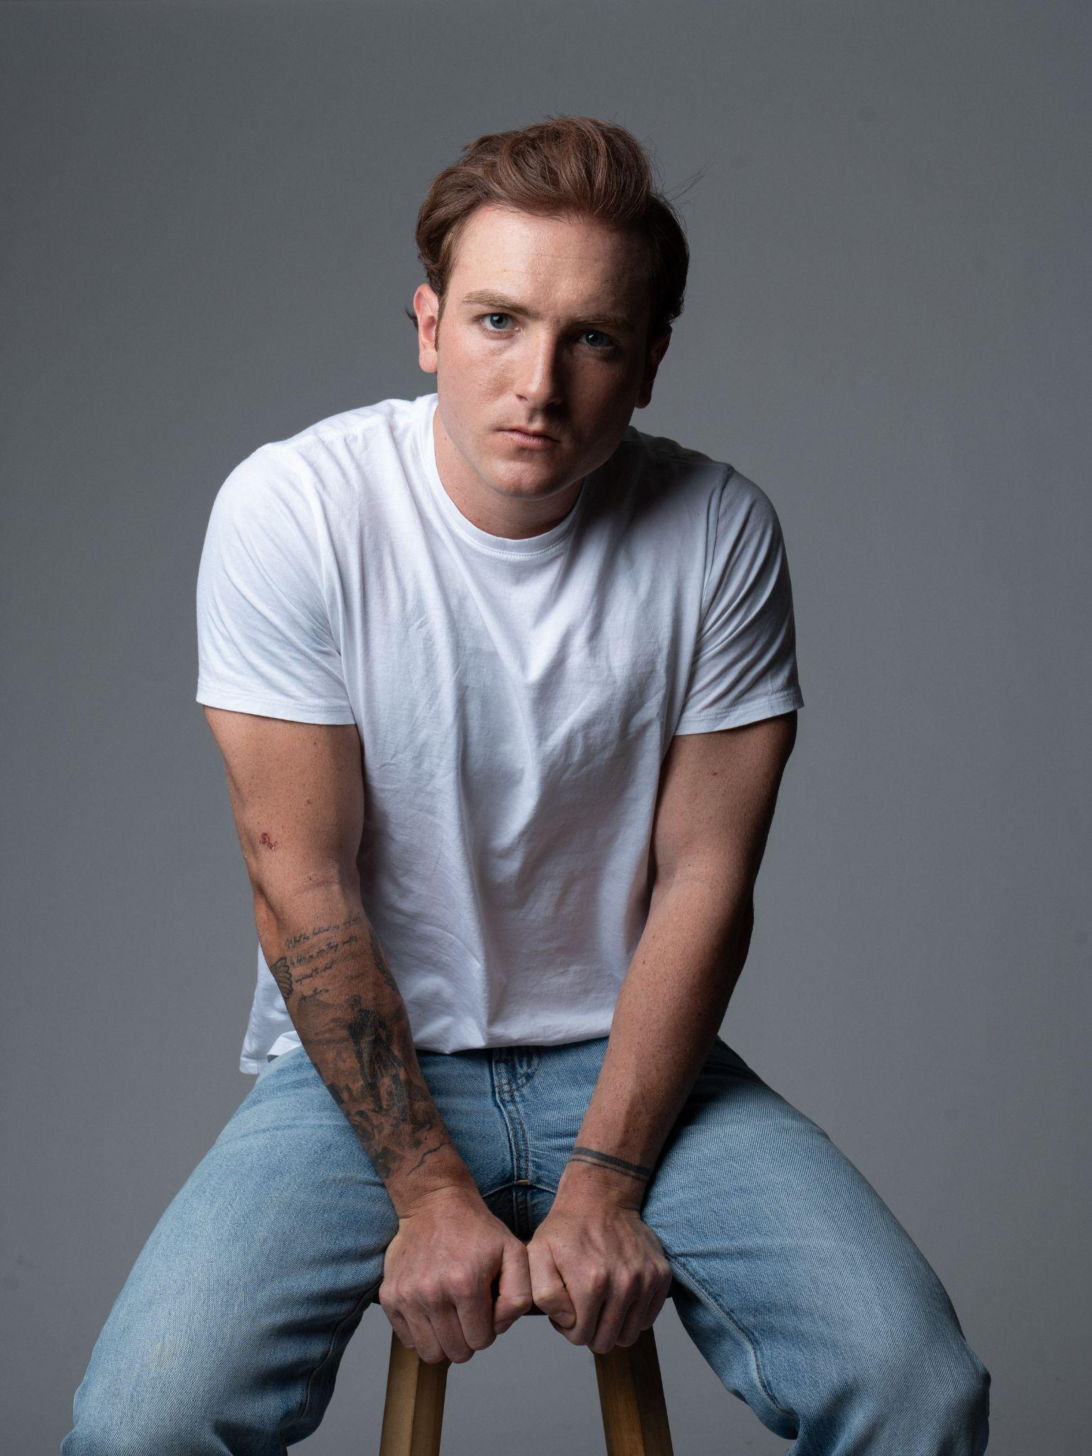
Hair: Auburn Shoe Size: 11
Eyes: Blue Vocal Range: Baritone
Age Range: 22-30 Weight: 175
Height: 5’10” Clothing Size: Shirt M, Pant 30x30, Chest 40

FILM
Take Me Out Lead Niko Volonakis- Dir.
Quick Lead Stacie Gentzler- Prod.
Frank and Smitty Lead El Firrelli- Dir.
F.A.S.T Day Player Warner Bros.
The Disposable Lead NYU
Whom Among Us Lead NYU

TELEVISION
The Consultants Lead Pilot POC
Killer Confessions- S1, E8 Supporting HBO MAX
Not Suitable For Work- S1, E1 Day Player FX, Hulu
American Love Story- S1, E3 Day Player FX, Hulu

THEATRE
Five Seconds of Blue Supporting NYC Theatre Festival 2026
Grease, Fall 2024 Lead Penn State University

COMMERCIAL
EVM Blockchain Lead Monad Crypto
Plaza Hotel Ad Campaign Lead Fairmont Hotels

TRAINING
Training: 2-Year Acting Conservatory – William Esper Studio (Acting: Suzanne Esper; Movement: Caitlin Rigney; Voice & Speech: Nancy Mayans; Alexander: Judith Grodowitz; Mask: Kathleen McNenny; Mime: Bill Bowers; Improv: Robert Grant; Stage Combat: Rick Sordelet; Dance: Lamine Thiam & Jeni Breen; Theatre History: David Kaplan), On-Camera Intensive – The Barrow Group (Quinn Vogt-Welch) | Education: B.A. Film Production – Penn State University

SKILLS
Athletic (4 year Division 1 Lacrosse Player, Boxing, Weightlifting, Football, Running, Swimming, Snowboarding) Acting (Meisner Technique, Alexander Technique, Guitar, Improv, Stage Combat, Mime, African Dance) Certifications (Valid Passport, Driver’s License, Motorcycle License, Boating License) Dialects (Southern, New York, Boston, Irish, British RP)

